BARANGAY RESIDENT INFORMATION SYSTEM
Database Management Systems - Final Project

SYSTEM NAME:
Barangay Resident Information System

GROUP MEMBERS:
1. Lynn S. Compahinay - 2024-1623-A 2-C
2. Johndel A. Zamora - 2023-8205-A 2-C
3. Josh Vincent D. Caspillo - 2024-5254-A 2-C
4. Clark S. Dadulla - 2025-S03495 2-C
5. Russel R. Delos Santos - 2024-4933-A 2-C

DATE: June 22, 2026

INSTRUCTOR:
Saylo, Kenette Roeven C.

SYSTEM OVERVIEW

The Barangay Resident Information System is a digital platform
designed to securely store and manage the records of residents
in a local community. It replaces traditional paper-based
filing systems with a centralized database that allows barangay
officials to quickly access accurate resident information,
track household demographics, manage barangay clearances, and
monitor health records.

The system reduces waiting times for citizens, minimizes
clerical errors, and helps local leaders make data-driven
decisions to better serve the community.

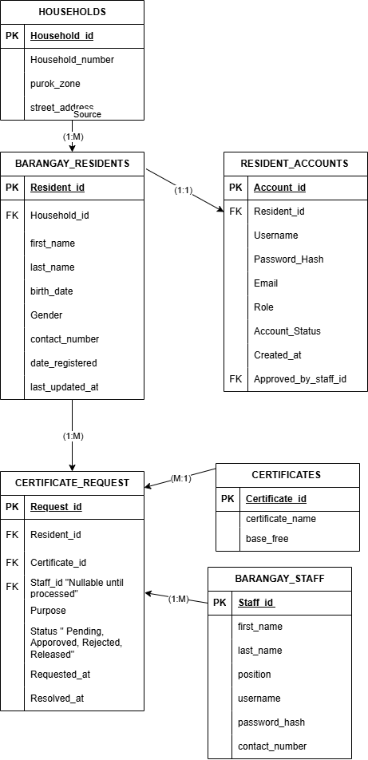
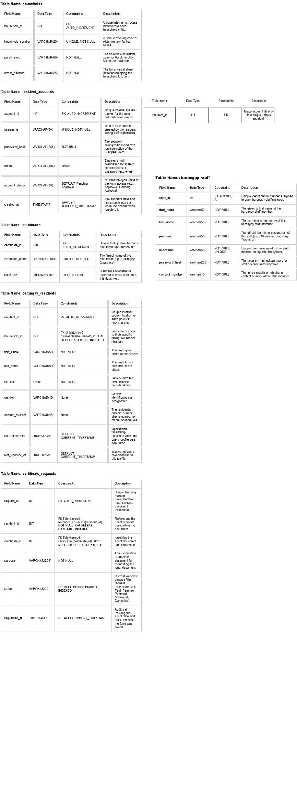
STORED PROCEDURES

ProcessCertificateRequest
Purpose: Process a certificate request (approve/reject/release)
Parameters:
- p_request_id: ID of the request to process
- p_staff_id: ID of the staff member processing it
- p_status: New status ('Approved', 'Rejected', 'Released')

Usage Example in SQL:
CALL ProcessCertificateRequest(1, 1, 'Approved');

VIEWS

1. certificate_request_summary
Shows all requests with resident and staff details

2. resident_dashboard_summary
Aggregated data per resident (total requests, pending, etc.)

SQL QUERIES IMPLEMENTED

INNER JOIN
SELECT cr.*, CONCAT(r.first_name, ' ', r.last_name) AS resident_name
FROM certificate_request cr
INNER JOIN barangay_residents r ON cr.resident_id = r.resident_id

LEFT JOIN
SELECT h.*, COUNT(r.resident_id) AS resident_count
FROM households h
LEFT JOIN barangay_residents r ON h.household_id = r.household_id
GROUP BY h.household_id

GROUP BY
SELECT status, COUNT(*) AS count
FROM certificate_request
GROUP BY status

HAVING
SELECT h.household_number, COUNT(r.resident_id) AS resident_count
FROM households h
LEFT JOIN barangay_residents r ON h.household_id = r.household_id
GROUP BY h.household_id
HAVING COUNT(r.resident_id) > 2

SUBQUERY
SELECT CONCAT(first_name, ' ', last_name) AS full_name
FROM barangay_residents
WHERE resident_id NOT IN (SELECT DISTINCT resident_id FROM certificate_request)

AGGREGATE FUNCTIONS
SELECT COUNT(*) AS total, SUM(amount_paid) AS total_collected
FROM certificate_request

DASHBOARD
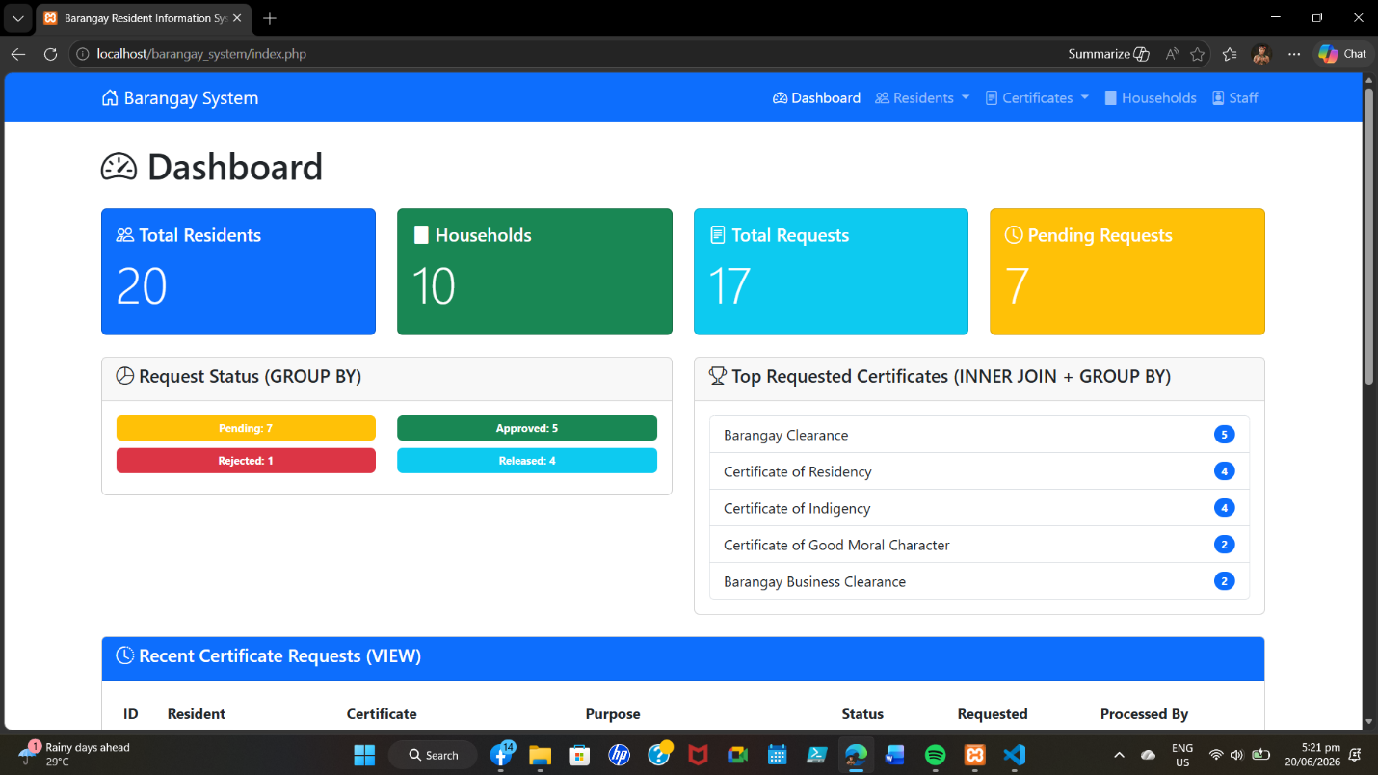

LIST
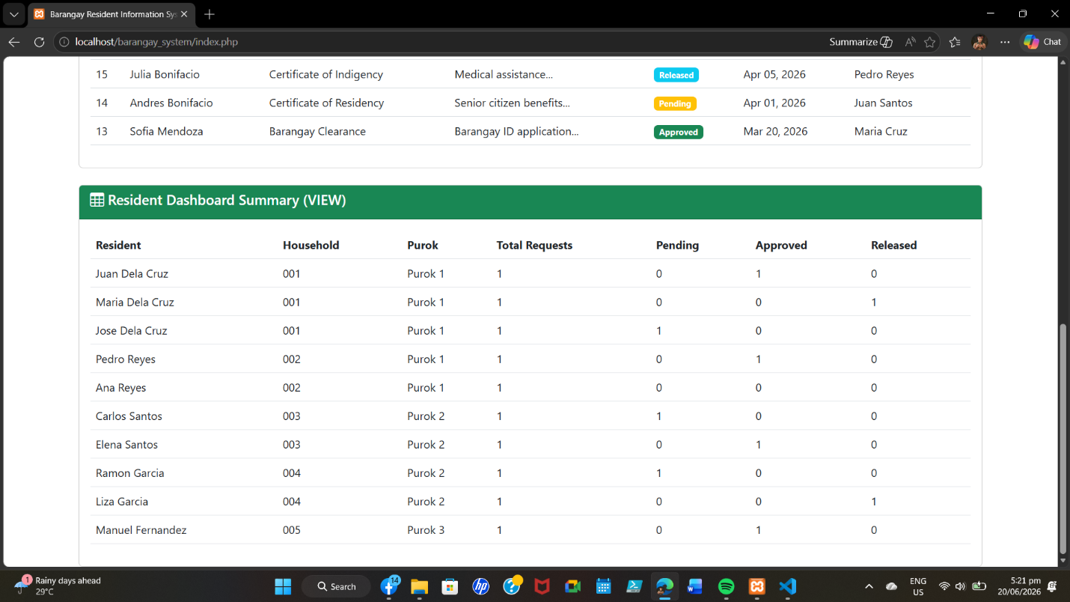

ADD
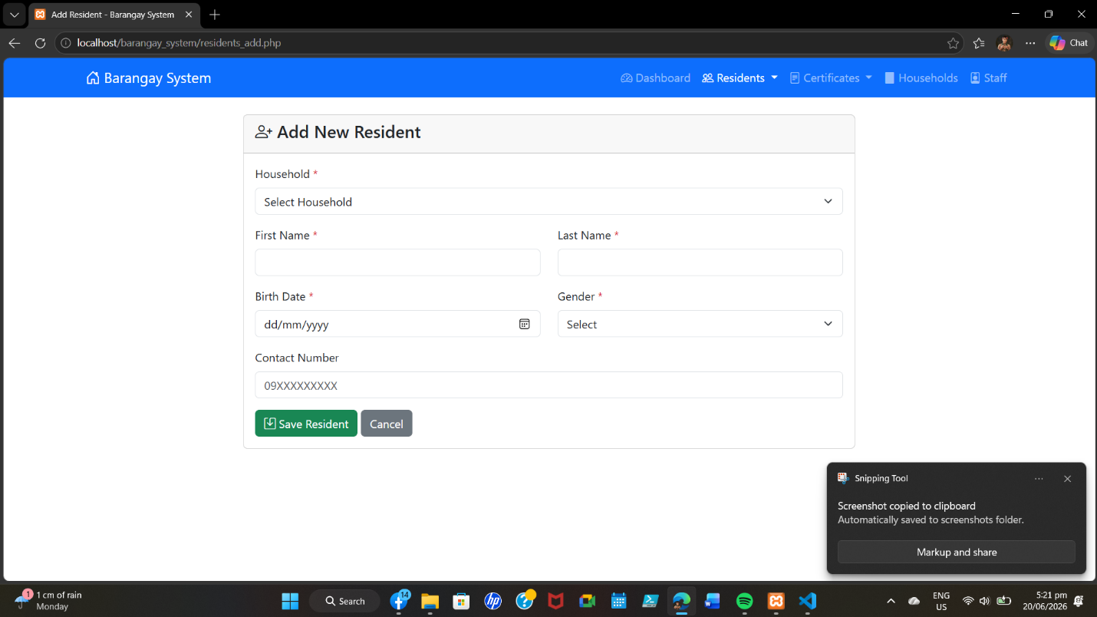

EDIT
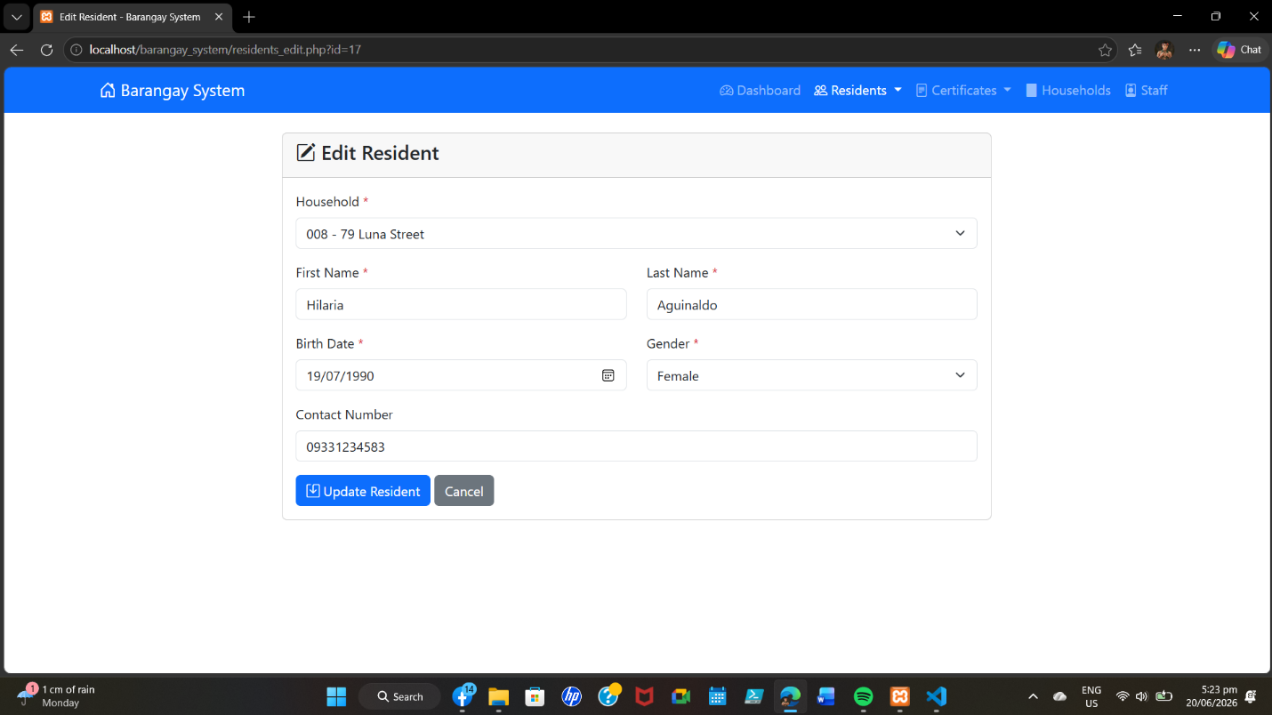

SEARCH
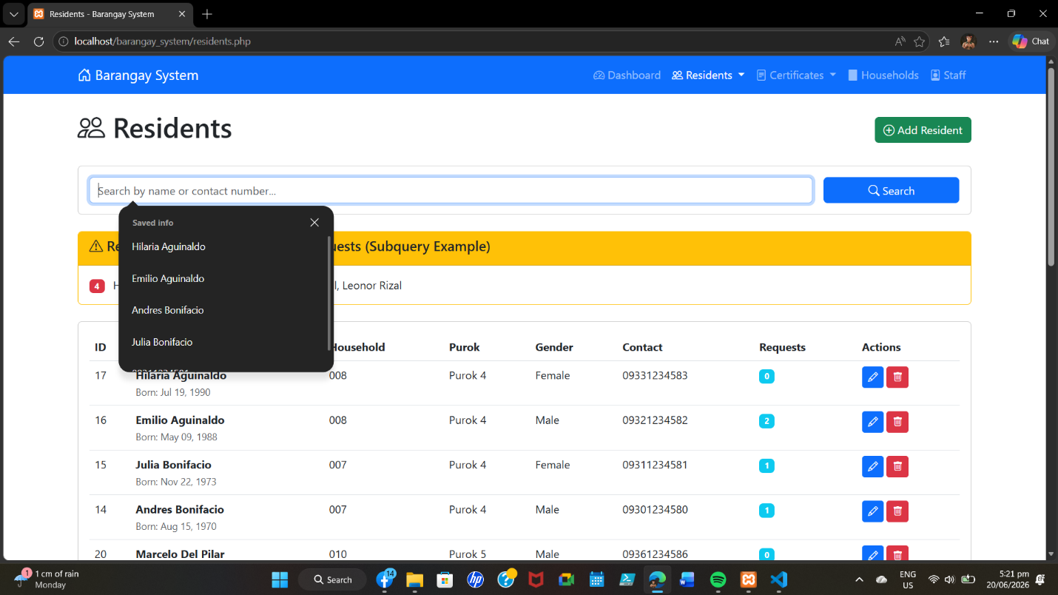

INDIVIDUAL CONTRIBUTION:
- Lynn S. Compahinay - 2024-1623-A
I designed the entire frontend user interface with custom CSS (style.css) and responsive design for desktop, tablet, and mobile. She developed the navigation menu, dashboard cards, statistics display, and all form designs. She implemented JavaScript validation (script.js) for client-side validation, auto-dismiss alerts, and confirmation dialogs. Her work made the system visually appealing, consistent, and user-friendly.

Files:
css/style.css, js/script.js, Navigation in all PHP files

- Johndel A. Zamora - 2023-8205-A
I built the complete certificate request system including CRUD operations and certificate types management (certificate.php). He developed the staff management system (staff.php, staff_add.php). He created SQL queries using GROUP BY for status statistics, HAVING for filtering large households, and aggregate functions for dashboard statistics. He implemented server-side validation for all forms to prevent SQL injection.

Files:
request.php, request_add.php, request_edit.php, request_delete.php, certificate.php, staff.php, staff_add.php

- Josh Vincent D. Caspillo - 2024-5254-A Josh implemented complete CRUD operations for residents with search functionality using LIKE queries. He developed the households management system with resident count display. He implemented SQL JOIN queries for resident-household relationships and subqueries for finding residents without certificate requests. He added client-side validation for all resident forms and resident request count in the residents list.

Files:
residents.php, residents_add.php, residents_edit.php, residents_delete.php, households.php, households_add.php

- Clark S. Dadulla - 2025-S03495 Clark designed the entire database schema including 6 tables, relationships, and constraints. He created the ERD, Data Dictionary, Stored Procedure (ProcessCertificateRequest), and all database views. He built the Dashboard (index.php) with real-time statistics and the database connection file (db_connect.php). He wrote the complete SQL script with seed data, aggregate queries, and indexes for performance optimization.

Files:
index.php, db_connect.php, sql/brgy_system.sql, ERD Diagram, Data Dictionary

- Russel R. Delos Santos - 2024-4933-A Russel performed comprehensive system testing, bug fixing, and quality assurance. He handled XAMPP setup, deployment, and database configuration. He created the README.txt file with complete documentation, organized the project folder structure, and formatted all documentation for final submission. He ensured cross-browser compatibility and verified all system features work correctly.

Files:
README.txt, Tested all files and features

